**Billy’s Sports Bar and Grill Market Analysis**

**By:**

**Carson Daspit 328009299, Ishan Dhanani 928008740, Merritt Butler 525008422 & Cynthia Tough 926007203**

**1.0: Introduction and Motivation**

Billy’s Sports Bar and Grill tasked us with researching potential geographic areas that were open to opportunity following the COVID-19 Pandemic. The purpose of this was to analyze and research county data in order to find competitive advantages that would allow for successful openings of new locations. One of the key factors in this analysis was focused on alcohol sales which is the main driver of revenue for Billy’s. During the pandemic, bars and other establishments that relied heavily on this same driver of revenue were forced to close due to local ordinances. We are now in a period where growth will continue to pick up as the economy and population return to normalcy. This research will highlight 3 counties that are believed to be prime locations for a new sports bar based on 4 key categories; Income, Population, Alcohol Sales, and Age Demographics.

One of the unique aspects of Billy’s Sports Bar and Grill is that they are looking to serve medium-sized markets (between 100,000 and 300,000 people). This helped us narrow our research to a certain set of counties that we found were underserved and prime locations for this opportunity. Texas is experiencing an influx of population growth from migration as well as internally. The ability to open in an emerging county and market is something we placed high emphasis on and we believe that this will pay large dividends. Population growth inherently leads to a larger customer base and based on our inference from the Age Demographics as younger customers reach the legal drinking age, we believe that this base will grow internally at an exponential rate.

A healthy economy is also a great indicator for new business and in recent history, Texas has been the leader of economic development in the United States. With favorable state policies to large corporations, the influx of relocations to this state has taken hold. Companies such as Tesla and Oracle have migrated to Texas from their home offices which can signal other businesses to follow this trend. This phenomenon helps two-fold as companies drive population growth and increase disposable income of their employees. These high-paid employees will look to spend their money and Billy’s Sports Bar and Grill will be ready to serve them.

With all of these factors in mind and our resulting analysis, the three counties we feel provide the best opportunity are Midland, Guadalupe, and Rockwall. Each one of them showed promise in the 4 key categories we laid out and while they did not claim the top spot in each one, their overall scores made them the most robust. As briefly mentioned before, we utilized a 4 pronged approach in this analysis focusing on Alcohol Sales, Age Demographics, Population Growth, and Income. Below we discuss each key performance indicator in greater detail.

**2.0: Analysis Methodology**

The primary focus of our analysis was capturing the future potential for each county with respect to present statistics. According to population data gathered in 2019, there are a total of 22 counties that fit the midsize population cap of 100,000 to 300,000. After subsetting this data, our team adopted a holistic approach to analyze key performance indicators for each county. Each prong consists of various metrics gathered to capture the total variance in each indicator.

*Alcohol Metrics*

The importance of alcohol to a sports bar does not need to be explained. In our analysis, we focused on specific metrics which provided insight into the overall alcohol sales and the health of bars in each county. One of the most important indicators was the sales of beer, wine, and liquor per county. To avoid significant skew towards higher populations, sales were normalized and a per capita alcohol sales metric was created.

Additionally, we investigated the “health” of bars in the selected counties. This comprehensive metric factors in new competition (bars opened in 2021) and how many bars did not renew their responsibility during the pandemic. Although there are multiple ways to interpret these statistics, we concluded that the optimal location was a bar with the lesser new competition and a moderate to high bar death rate. With lesser competition, Billy’s will be able to stand out as the new bar. Along with the novelty of a new bar, Billy’s can quickly take advantage of the customers of the bars that closed down and cement themselves in the county.

*Age/Demographic Metrics*

The legal drinking age in Texas is 21. Although minors are able to enter the bar and purchase food, they are not able to purchase alcohol without a valid ID. Therefore, we focused on two main target age groups to demonstrate the present and future potential customers. The first group consists of ages 20-24. This bin contains the legal limit age and captures most of the college-aged population in these towns. Going to bars to watch sporting events and drink alcohol is a common college tradition across the United States and Billy’s will be able to capitalize on this with the target demographic. We also factored in future growth by focusing on the 15-19 age group. Although not yet legal, this is the age group that can visit a sports bar for its food and atmosphere. It is paramount to keep this age group in mind when thinking about future revenue and expansion.

Furthermore, we looked into each country's overall population growth from 2010 through 2019. We studied the yearly growth rate as well as total percentage growth from 2010 through 2019. This metric tied in with some of our qualitative research into the surrounding area. Although we did not pick the counties with the most boom, we kept these the largest growers under consideration as we finalized our counties. For example, although Hays is one of the fastest-growing counties in the United States, we chose Guadalupe due to its growth rate and its proximity to Hays.

*Income Metrics*

With the goal of maximizing Billy’s revenue, we focused on income per capita for each county. According to the Bureau of Labor Statistics, about 1% of income is spent on alcohol. After this calculation, we discovered that Midland and Rockwall County took the top spots and Guadalupe County was in the top half. Furthermore, we calculated the compound annual growth rate for income further confirming that the previous standings.

**3.0: Individual County Analysis**

*Guadalupe:*

Guadalupe County is located near San Antonio and borders Comal County and Hays County. Its proximity to Hays, the fastest growing county in the United States, makes it a target for population growth. With the large influx to Hays, people will look for a geographically close area that boasts a less overall cost of living. Guadalupe has the 9th highest mean total alcohol sales, the 7th highest mean liquor sales, the 11th highest mean beer sales, and the 6th highest mean wine sales. Although these rankings seem unimpressive, they are explained by the population of Guadalupe County being in the middle of the 22 target counties. Guadalupe County’s total population of legal drinking age persons in 2018 was 9,921 and in 2019 it rose to 10,149. Guadalupe also has an impressive ratio of old to new establishments with 5,947 old and 28 new which means Billy’s would not face significant competition compared to the other target counties. Furthermore, during the pandemic, Guadalupe County had a moderate loss in bars. In 2020, 193 bars were lost, and in 2021, 311 bars were lost. This decline when compared to the total number of bars shows potential for a new bar to establish itself within the county.

The per capita personal income of Guadalupe County in 2019 was $45,797 and total spending came out to be $114,214,055. The per capita personal income is fairly low, but we expect to see this rise as the county’s population and the economy grow.

*Rockwall:*

Rockwall County is located next to Dallas County and borders the city of Dallas. Out of the 22 counties we analyzed, Rockwall County has the 6th highest mean total alcohol sales, the 6th highest mean liquor sales, the 15th highest mean beer sales, and the highest mean wine sales. There are a fair amount of old establishments, 8,816, and not that many new establishments, 31 giving Billy’s a competitive advantage. These are impressive rankings considering Rockwall is close to the 100,000 threshold. Because Rockwall just recently broke the 100,000 threshold, Rockwall ranks last in our target population of males aged 20 to 24, expected as Rockwall County has the smallest population out of our 23 initial counties.

During the COVID-19 pandemic, Rockwall County lost 89 bars in 2020 and 116 in 2021. Rockwall County also had a higher per capita personal income in 2019 with it being $62,237. The total spending came out to be $65,295,952. With a 33% growth from 2010, Rockwall still has vast room for growth.

*Midland*:

Lastly, we analyzed Midland County. Located on the Permian Basin, the largest oil basin in the United States, Midland potentially has the highest long-term growth potential out of every county studied. Midland County has the 3rd highest total mean alcohol sales, the 5th highest mean liquor sales, the 2nd highest mean beer sales, and the 3rd highest mean wine sales. Midland County also had the highest per capita personal income in 2019 at $130,983. The total spending was also high with it being $231,619,859. This shows us that the overall population has a large disposable income. With 13,297 old establishments and high alcohol sales, the population of Midland seems to frequent bars for a variety of reasons.

However, with there being so many old establishments, it presents the potential for competition. This is addressed through the large bar death number. In 2020 and 2021, Midland lost 685 and 344 establishments respectively. This decline presents a low bar of entry and a high probability of Billy’s being warmly received. Additionally, Billy’s can take advantage of a population looking for new bars. Furthermore, the population has a growth rate of 29%. This will only increase as oil exploration increases in the area.

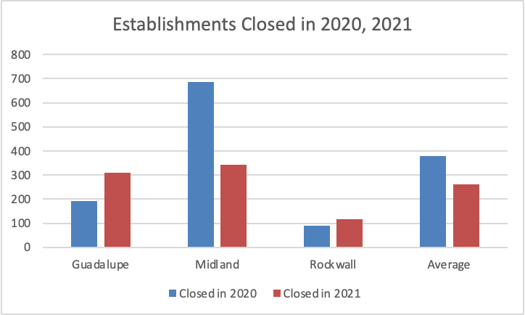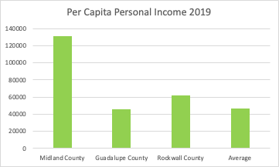

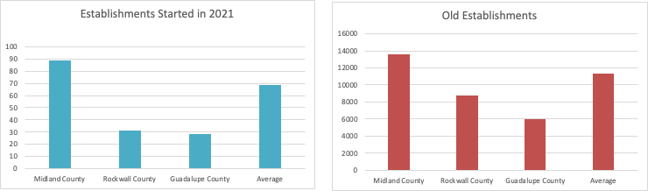

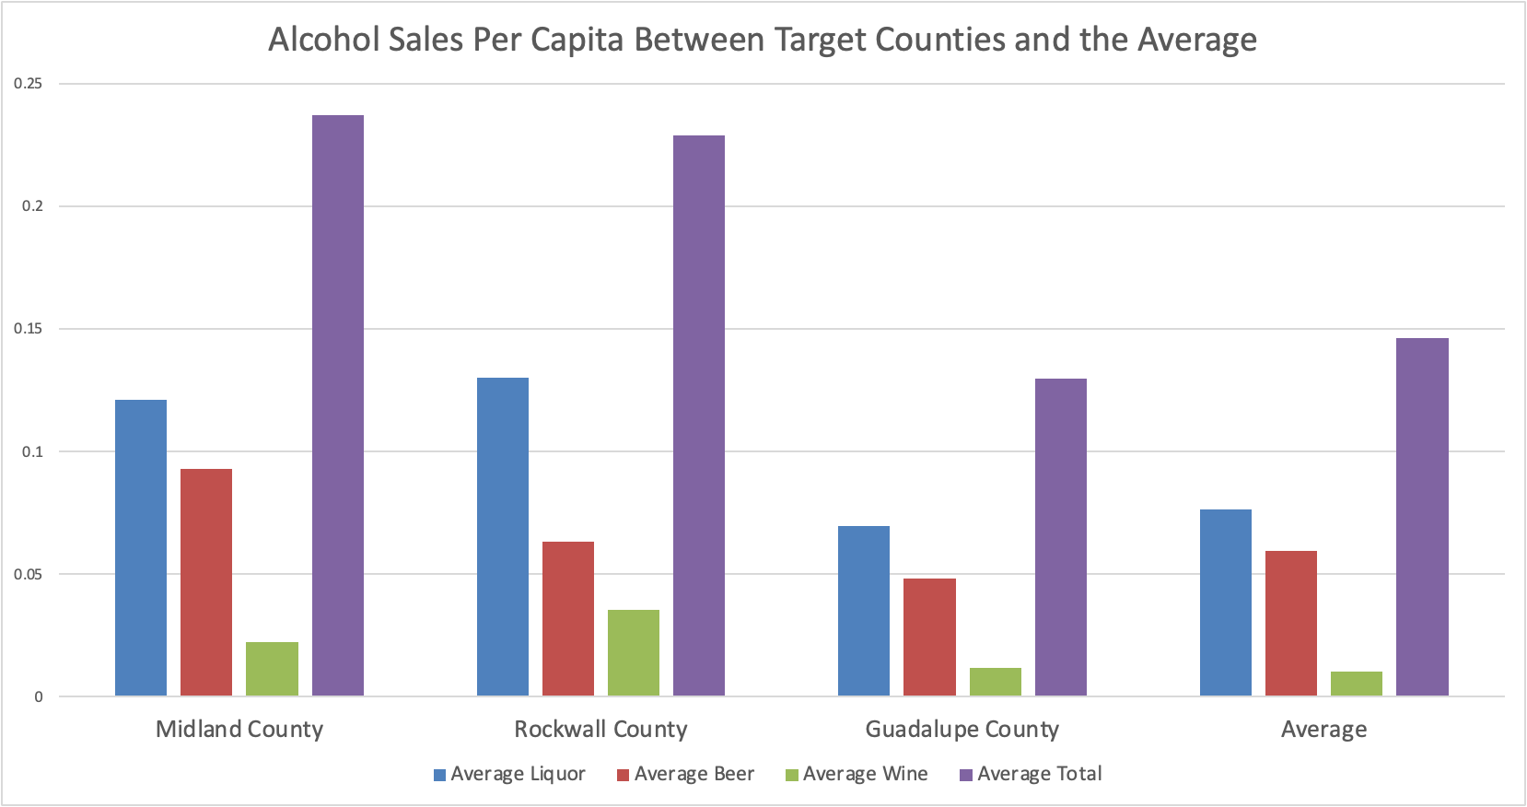

**4.0: Growth Potential**

Our target countries have had extraordinary growth when compared to counties in the rest of Texas. Below is a graph displaying population growth from 2010 to 2019 with our counties highlighted. Guadalupe, Rockwall, and Midland are in the top 6 counties with growth percentages of over 25%. Rockwall is particularly impressive as it started below the 100,000 threshold and ended above the cutoff with a growth rate of 32%. Fitting a basic ARIMA model supports our hypothesis that these countries are not done growing.

Additionally, as stated above, all Guadalupe and Rockwall border major cities while Midland is at the heart of the oil-rich Permian Basin. This will be covered further in our SWOT analysis. 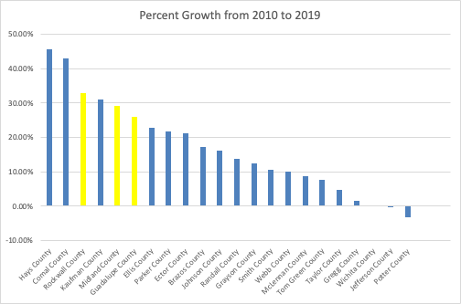

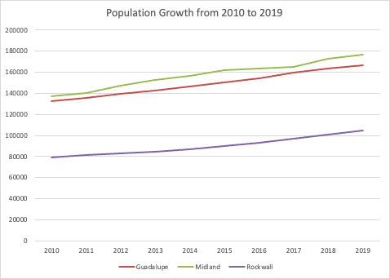

**5.0: SWOT Analysis**

Rockwall County:

*Strengths*

* Strong Growth Potential: We see tremendous potential for growth in the future for Rockwall County. A larger population translates into economic growth by providing more chances for small businesses to prosper and be fully staffed by potential employees.
* Proximity to Dallas: Rockwall’s proximity to Dallas creates incentives for those employed in Dallas to commute from and live in, say, Rockwall, a city categorized by a lower cost of living relative to Dallas.
* Resilience to Economic Distresses: We believe Rockwall will be able to withstand the economic factors that tend to hurt new businesses. The low bar death rate in Rockwall County shows its ability to remain strong when faced with competition and market fluctuations.

*Weaknesses*

* Low Total Population: Rockwall’s low population relative to other counties indicates a low target population for potential customers compiled with a low existing customer base.
* Declining Population Growth: Rockwall County’s population growth has declined since 2019. This fact compiled with its already low population is unencouraging and therefore presents a potential hindering of business growth.

*Opportunities*

* Expected Future Job Growth: We expect future job growth in Rockwall County due to its nearness to Dallas. This creates the opportunity to attract a larger customer base.
* Low Competition: Rockwall County ranks low in existing establishments, therefore, creating the opportunity for expansion without the hindrance of competition.

*Threats*

* Inner City Crime Spillovers: While proximity to the city of Dallas can be seen as a major strength of Rockwall County, Dallas has one of the highest crime rates in America, also one of the highest crime rates relative to similar communities of all sizes. This poses the threat of crime making its way into smaller and near counties like Rockwall, which can negatively affect and threaten the commercial and residential growth of the county.

Midland:

*Strengths*

* Promising in All Deciding Factors: With a high income per capita and the highest mean total alcohol sales, we find that the combination of these two statistics sets Midland County apart from the others. Midland ranks number one in beer sales and we see this to be a promising factor. Its high growth rate relative to a majority of our other counties deems Midland as a top contender for potential business opportunities.
* Expected Future Job Growth: We expect future job growth in Midland County. Defined by the high population growth rate and the oil and gas sector, we expect Midland County to draw more and more people to the area each year.

*Weaknesses*

* Low Target Population: Midland County ranks low for our target population which is expected as the County is populated with men employed in the oil and gas industry who tend to fall within the older age groups.
* Potential Difficulty of Staying in Business: Midland County is characterized by a high bar death rate which poses the possibility of business complications and inability to withstand economic fluctuations.

*Opportunities*

* Located within the Permian Basin: Midland County is located within the largest basin in the United States suggesting that Midland County is a hotspot for job growth. As Midland County becomes more populated with oil and gas workers, we expect the opportunity for alcohol sales and income growth.
* Top Contender for Business Opportunities: The county’s rural location and lack of entertainment make Midland a promising county for opening a bar and grill.

*Threats*

* Existing Competition: We expect competition to be a deterrent to business expansion in Midland County. With a large number of new establishments, Billy’s will be faced with existing competition upon arrival to the county.
* Potential Economic Disasters: Midland County lacked resilience when the COVID-19 pandemic hit. A substantial number of establishments failed in 2020, and this number is inconsistent with similar counties, signifying Midland County’s difficulty in keeping businesses alive when faced with hardship. This number dropped in 2021, and we expect it to continue on this trend.

Guadalupe

*Strengths*

* Proximity to San Antonio: Guadalupe County’s close proximity to San Antonio is a promising factor as San Antonio is a hot spot for tourism and entertainment. This makes Guadalupe County a prime location for workers to live in and commute to San Antonio as it is characterized by a cheaper cost of living.
* Promising Future Growth: We believe Guadalupe County will continue to experience strong growth in the future as its population has been on an upward trend. This suggests that Guadalupe county is attracting more and more people each year who are potential future customers of Billy’s.

*Weaknesses*

* Low Target Population: Guadalupe county ranks low in our target population. This is a slightly unattractive feature of the county as we initially narrowed down our counties using this metric.
* High Poverty Rate: Guadalupe ranks high in poverty amongst all Texas counties and indicates potential economic development concerns.

*Opportunities*

* Border Shared with Hays and Comal County: Guadalupe County shares a border with both Hays and Comal County, the two fastest-growing counties in America. This tells us that this area is highly attractive and we expect spillover opportunities from Hays and Comal County into Guadalupe County.
* Limited Competition: Guadalupe County is characterized by a low number of new and old establishments. This eliminates the threat of new and existing competition and offers Billy’s the opportunity to thrive and succeed without the added barrier of competition.

*Threats*

* Potential Flash Flooding: The Guadalupe River poses the potential threat of dangerous flash flooding. A flash flood presents possible negative externalities that could spill over and affect the residents and businesses of the county.

**6.0: Conclusion**

In conclusion, we have found 3 counties in Texas that would provide the best opportunity for the expansion of Billy’s Sports Bar and Grill. We implemented a robust strategy to examine these locations based on Alcohol Sales, Age Demographics, Population Growth, and Income. After processing all data available we find that Guadalupe, Midland, and Rockwall counties are prime candidates for this project. Each location showed promise in all aspects and after taking into consideration the current economic climate we expect the post covid bar industry to gain its traction once again. Overall, we are pleased with our recommendations for expansion and believe that these three counties will provide successful opportunities for Billy’s.

**7.0: Appendix**

All code for this project is stored in a [Github repository](https://github.com/ishandhanani/ecmt673pipeline/blob/main/README.md). We primarily used R and Excel for the analysis in this paper. R was used to create a data pipeline to process relevant files and create summaries and graphs. These were then written to excel for further analysis and readability. The framework also renames columns and pre-processes data for further forecasting or machine learning analysis. This format can theoretically be used to analyze county data from every state given that the initial data set matches the format of the TX datasets.

To replicate this study, Rstudio is required along with the packages listed in each file. Each file from the repository should be stored in a folder along with the relevant data files found on Professor Schulaman’s website. That’s all! Each file pulls data from the master Population Subset Pipeline and runs it in the background. This reduces overall clutter in Rstudio itself.

However, if you do not want to replicate the analysis and just want to view the output, the Github README.md file contains a link to a folder with our final excel spreadsheets. These can all be downloaded and viewed locally. Each file has a master data sheet followed by a subset of the data containing summaries and visuals.

Citations

*10.6% Poverty Rate in Guadalupe County, Texas*, www.welfareinfo.org/poverty-rate/texas/guadalupe-county.

*Massive Flooding Washes Away RV from Park along Guadalupe River*, www.msn.com/en-us/news/us/live-massive-flooding-washes-away-rv-from-park-along-guadalupe-river/ar-AAPvIRm.

“Dallas, TX Crime Rates.” *NeighborhoodScout*, www.neighborhoodscout.com/tx/dallas/crime.